Math Assignment
Luran(Lori) Zhou
2012/2/24

Year 11 Mathematic B
Teacher: Miss Roach

This assignment is about a cyclone is bearing down on the coast of China due east of Hong Kong and due south of Shang Hai, moving directly towards the town Yi Chang. The angles and the distances about the cyclone and towns were calculated by using Trigonometric functions and application.

Q1.Choose a town between Hong Kong and Shang Hai anduse the Internet site www.wolframalpha.com to find the latitude and the longitude of all the towns.
City | The latitude | the longitude
Shang Hai | 31° 13' 48" N | 121° 28' 12" E
Hong Kong | 22° 17' 2" N | 114° 9" E
Yi Chang | 30 °42' N | 111° 16' 48" E
cyclone | 22° 17' 2" N | 121° 28' 12" E

Yi Chang was chosen as the town.
The websitewww.wolframalpha.com was used to find the longitude and the latitude of all the towns and cities.
The latitude and the longitude of Hong Kong: 22° 17' 2" N, 114° 9" E
The latitude and the longitude of Shang Hai: 31° 13' 48" N, 121° 28' 12"E
The latitude and the longitude of Yi Chang: 30 °42' N, 111°16' 48" E
The latitude and the longitude of the cyclone: 22° 17' 2" N,121° 28' 12" E

Q2. Use the Internet Sitehttp://www.movable-type.co.uk/scripts/latlong.html to find and record the distance and initial bearing between the towns and cyclone.

From | To | Distance | Initial bearing
Hong Kong | Shang Hai | 1231km | 034°33′47″
Shang Hai | cyclone | 994.8km | 180°00′00″
Hong Kong | cyclone | 753.1km | 088°36′38″
Yi Chang | Hong Kong | 978.3km | 162°22′04″
Yi Chang | cyclone | 1379km | 130°19′00″

The website http://www.movable-type.co.uk/scripts/latlong.html was used to find all the data above.

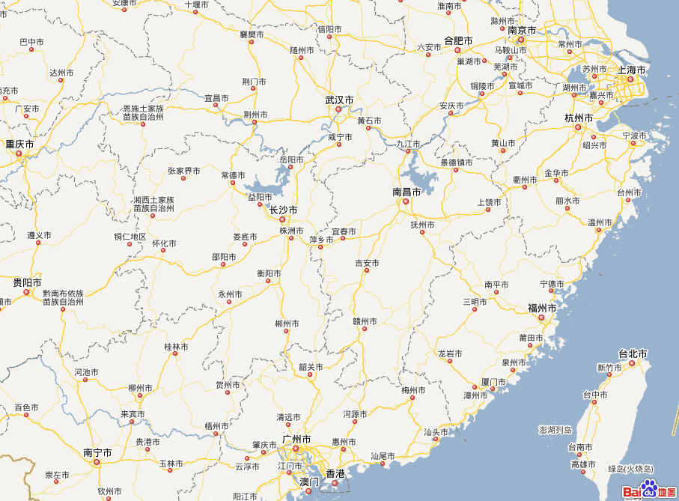
A
Yi Chang

1231km

1379.0km

D
Cyclone
753.1km

994.8km

978.3km

Shang Hai
C
B
Hong Kong

Q3. Using measurements and sine and cosine rule to find all angles from the above diagram.

The cosine rule formula was used to calculate$∠A$:
$$cosA=\frac{b^{2}{+c}^{2}-a^{2}}{2bc}$$
$$cos∠A=\frac{{978.3}^{2}{+1379.0}^{2}-{753.1}^{2}}{2×978.3×1379.0}$$
$$∠A=\cos^{-1}(\frac{{978.3}^{2}{+1379.0}^{2}-{753.1}^{2}}{2×978.3×1379.0})$$
$$∠A=31°51'50″$$

The sine rule formula was used to calculate $∠ADB$and$∠ABD$:
$$\frac{a}{sin A}=\frac{b}{sinB}=\frac{c}{sinC}$$
$$\frac{BD}{sin A}=\frac{AB}{sin∠ADB}$$
$$\frac{753.1}{sin31°51'50″}=\frac{978.3}{sin∠ADB}$$
$$∠ADB=\sin^{-1}（\frac{978.3×\sin{31°{51}^{'}{50}^{″}}}{753.1}）$$
$$∠ADB=43°{17}^{'}44″$$

$$\frac{BD}{sin A}=\frac{AD}{sin∠ABD}$$
$$\frac{753.1}{sin31°51'50″}=\frac{1379.0}{sin∠ABD}$$
$$∠ABD=\sin^{-1}（\frac{1379.0×\sin{31°{51}^{'}{50}^{″}}}{753.1}）$$
$$∠ABD=75°9^{'}34″$$
According to diagram, $∠ABD$ is obtuse
So $∠ABD=180°-75°9^{'}34″=104°{50}^{'}26″$

Verify the angles:
$$∠ABD+∠ADB+∠A=104°{50}^{'}26″+43°{17}^{'}44″+31°51'50″=179°{59}^{'}{36}^{″}≈180°$$
In △ABD, the three angles can be added into 180°.

The cosine rule formula was used to calculate$∠A$:
$$cosA=\frac{b^{2}{+c}^{2}-a^{2}}{2bc}$$
$$cos∠C=\frac{{CD}^{2}{+CB}^{2}-{BD}^{2}}{2×CD×CB}$$
$$cos∠C=\frac{{994.8}^{2}{+1231}^{2}-{753.1}^{2}}{2×994.8×1231}$$
$$∠C=\cos^{-1}(\frac{{994.8}^{2}{+1231}^{2}-{753.1}^{2}}{2×994.8×1231})$$
$$∠C=37°42'4″$$

The sine rule formula was used to calculate $∠CBD$and$∠CDB$:
$$\frac{a}{sin A}=\frac{b}{sinB}=\frac{c}{sinC}$$
$$\frac{BD}{sin C}=\frac{CD}{sin∠CBD}$$
$$\frac{753.1}{sin37°42'4″}=\frac{994.8}{sin∠CBD}$$
$$∠CBD=\sin^{-1}（\frac{994.8×\sin{37°{42}^{'}4^{″}}}{753.1}）$$
$$∠CBD=53°{52}^{'}57″$$

$$\frac{BD}{sin C}=\frac{CB}{sin∠CDB}$$
$$\frac{753.1}{sin37°42'4″}=\frac{1231}{sin∠CDB}$$
$$∠CDB=\sin^{-1}（\frac{1231×\sin{37°{42}^{'}4^{″}}}{753.1}）$$
$$∠CDB=88°{24}^{'}22″$$

Verify the angles:
$$∠CDB+∠CBD+∠C=88°{24}^{'}{22}^{″}+53°{52}^{'}{57}^{″}+37°{42}^{'}4^{″}=179°{59}^{'}{23}^{″}≈180°$$
In△CBD，the three angles can be added to 180°.
Q4. Find the area formed by the lines joining these towns from the above diagram.

The surface areaformula was used:$$SA =\frac{1}{2}bc×sinA$$
$$SA ∆ABD=\frac{1}{2}×AB×AD×sin∠BAD$$
$$=\frac{1}{2}×978.3×1379.0×sin31°51'50″$$
$$=356090.17{km}^{2}$$

$$SA ∆CBD=\frac{1}{2}×CB×CD×sin∠BCD$$
$$=\frac{1}{2}×994.8×1231×sin37°42'4″$$
$$=374447.03{km}^{2}$$

The area of triangle ABD is 356090.17km²，the area of triangle CBD is 374447.03Km².

Q5. Verify the bearing using trigonometry and the latitude and longitude values from the diagram below.
Shang Hai
C
E

F
A
Yi Chang

1231km

1379.0km

978.3km

994.8km

753.1km

D
Cyclone
B
Hong Kong

$$∠FAD=∠ADB=43°{17}^{'}{44}^{″}$$
$$∠EAB=∠EAF+∠FAD+∠BAD=90°+43°{17}^{'}{44}^{″}+31°{51}^{'}{50}^{″}$$
$$=165°9'34″$$
The initial bearing of Yi Chang to Shang Hai calculated by using latitude and longitude is 162°22′04″, and the trigonometry calculation is $165°9'34″$

Q6. Write any assumptions, strengths and/or limitations relating to the calculations above.
Assumptions:
- It wasassumed to happenin 2 dimension not 3 dimensions. The earth should be a sphere, but it consider as a flat surface. The distance between the towns and the cyclone is a straight line not curved line.
- It’s was assumed that the centre of the towns, cities and cyclone are joined together.
- The calculations which were provided by the websites were assumed to be accurate.
Limitations:
- The calculations of the questions were not very accurate, they were approximate value.For example, most of the angles were approximate to the neatest seconds.
- The distance between each town and cityfrom the websites may not be accurate.

Q7. Find the distance from the weather to each town when the angle to the other town has reduced by a half.
D’
1231km

1379.0km

978.3km

994.8km

753.1km

E
D
Cyclone
A
Yi Chang

B
Hong Kong
Shang Hai
C

In the diagram above, the cyclone was assumed to move directly to the town Yi Chang on AD. And when the cyclone moved to D’, the angle BCD was divided in half by CD’. The cyclone D’ and each town are joined together, A, E, D’, D are on the same line.
According to Q2,
$∠A=31°{51}^{'}{50}^{″}$,$∠ADB=43°{17}^{'}{44}^{″}$,$∠ABD=104°{50}^{'}26″$,
$∠C=37°42'4″$, $∠CBD=53°{52}^{'}{57}^{″}$, $∠CDB=88°{24}^{'}22″$

∵CD’ divided ∠BDC in half
∴$∠BCD^{'}=∠DCD^{'}=\frac{1}{2}×∠BDC=\frac{1}{2}×37°{42}^{'}4^{″}=18°51'2″$
$$∠CDD^{'}=∠CDB-∠ADB=88°{24}^{'}{22}^{″}-43°{17}^{'}{44}^{″}=45°6'38″$$
In △CDD’, $∠DCD'=18°{51}^{'}2^{″}$,$∠CDD'=45°6^{'}{38}^{″}$, CD=994.8km
$$∠CD^{'}D=180°-∠DCD^{'}-∠CDD^{'}=180°-18°{51}^{'}2^{″}-45°6^{'}{38}^{″}=116°2'20″$$
The sine rule formula was used:
$$\frac{a}{sin A}=\frac{b}{sinB}=\frac{c}{sinC}$$
$$\frac{CD'}{sin ∠CDD'}=\frac{CD}{sin∠CD'D}$$
$$\frac{CD'}{sin45°6^{'}{38}^{″}}=\frac{753.1}{sin116°2'20″}$$
$$CD'=\frac{753.1×sin45°6^{'}{38}^{″}}{sin116°2'20″}$$
$${CD}^{'}=784.41km$$
$$\frac{DD'}{sin ∠DCD'}=\frac{CD}{sin∠CD'D}$$
$$\frac{DD'}{sin18°51'2″}=\frac{753.1}{sin116°2'20″}$$
$$DD'=\frac{753.1×sin18°51'2″}{sin116°2'20″}$$
$${DD}^{'}=270.81km$$
$${{AD}^{'}=AD-DD}^{'}=1379-270.81=1108.19km$$
In △CBD’, $∠DCD'=18°{51}^{'}2^{″}$, CD’=784.41Km, CB=1231km
The cosine rule formula was used
$$a^{2}=b^{2}+c^{2}-2bccosA$$
$${BD^{'}}^{2}={CB}^{2}+{CD^{'}}^{2}-2×CB×CD^{'}×cos∠BCD'$$
$${BD^{'}}^{2}={1231}^{2}+{784.41}^{2}-2×1231×784.41×cos18°{51}^{'}2^{″}=303024.3686$$
$${BD}^{'}=550.48km$$

The distance from the weather to Hong Kong is550.48km;from the weather to Yi Chang is 1108.19km and from the weather to Shang Hai is 784.41km.

Q8. Write any assumptions or approximations that are relevant to the calculations.
Assumptions:
- The cyclone was assumed to move straight on a line to the town.
- The centre of the town, cities and cyclone were joined together.
- It happened in a flat surface not on a sphere.
- The data form the websites were accurate enough.
Approximations:
- All the angles were approximate to the nearest seconds, and all the distances were approximate to 2 decimal place.
- The calculations from the websites were approximate numbers.

